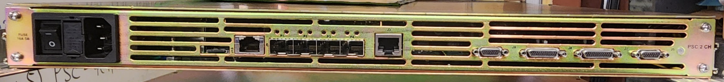
DCCT
P/S#1
P/S#2
Network (IOC)
SD Card
One-Wire Port (Unused)
“SFP3”
Event Reciever/Fiber Timestamp
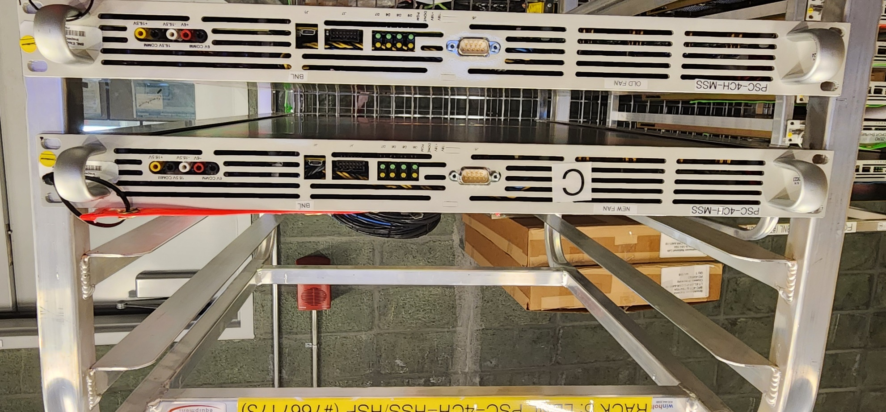
COM Port (Unused)
Status LEDs
FPGA JTAG
Micro-USB Serial Console

Voltage Testpoints

CH1
CH2
CH3
CH4
Network

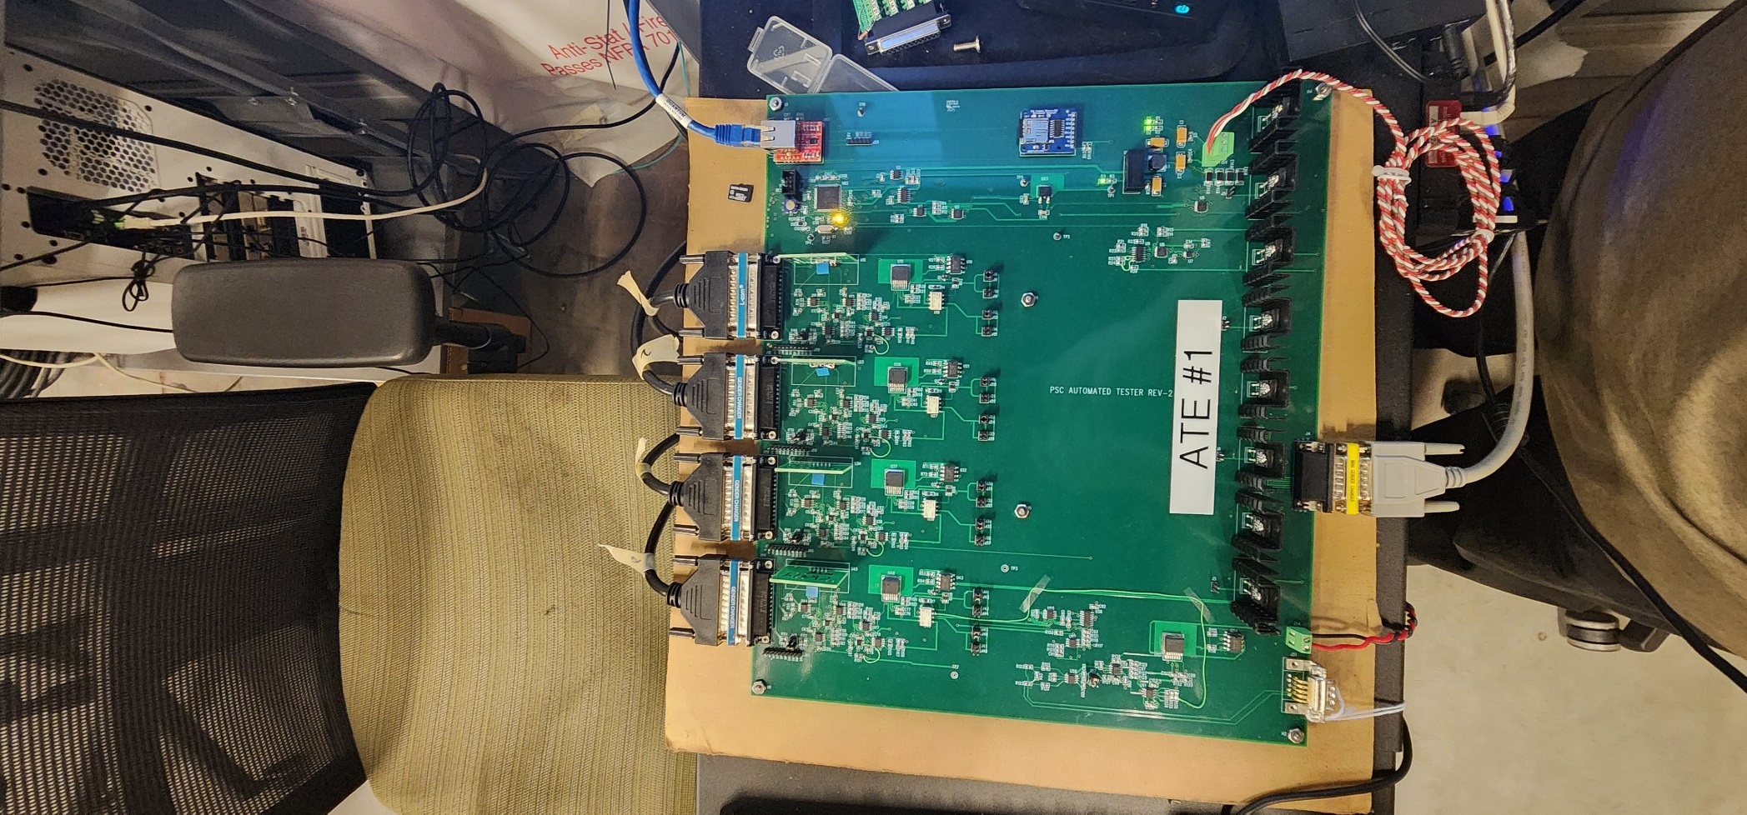
+/-15V Supply
DCCT Cable
Current Shunt
Jumpers
SD Card
Heartbeat LED
Tuning Boards

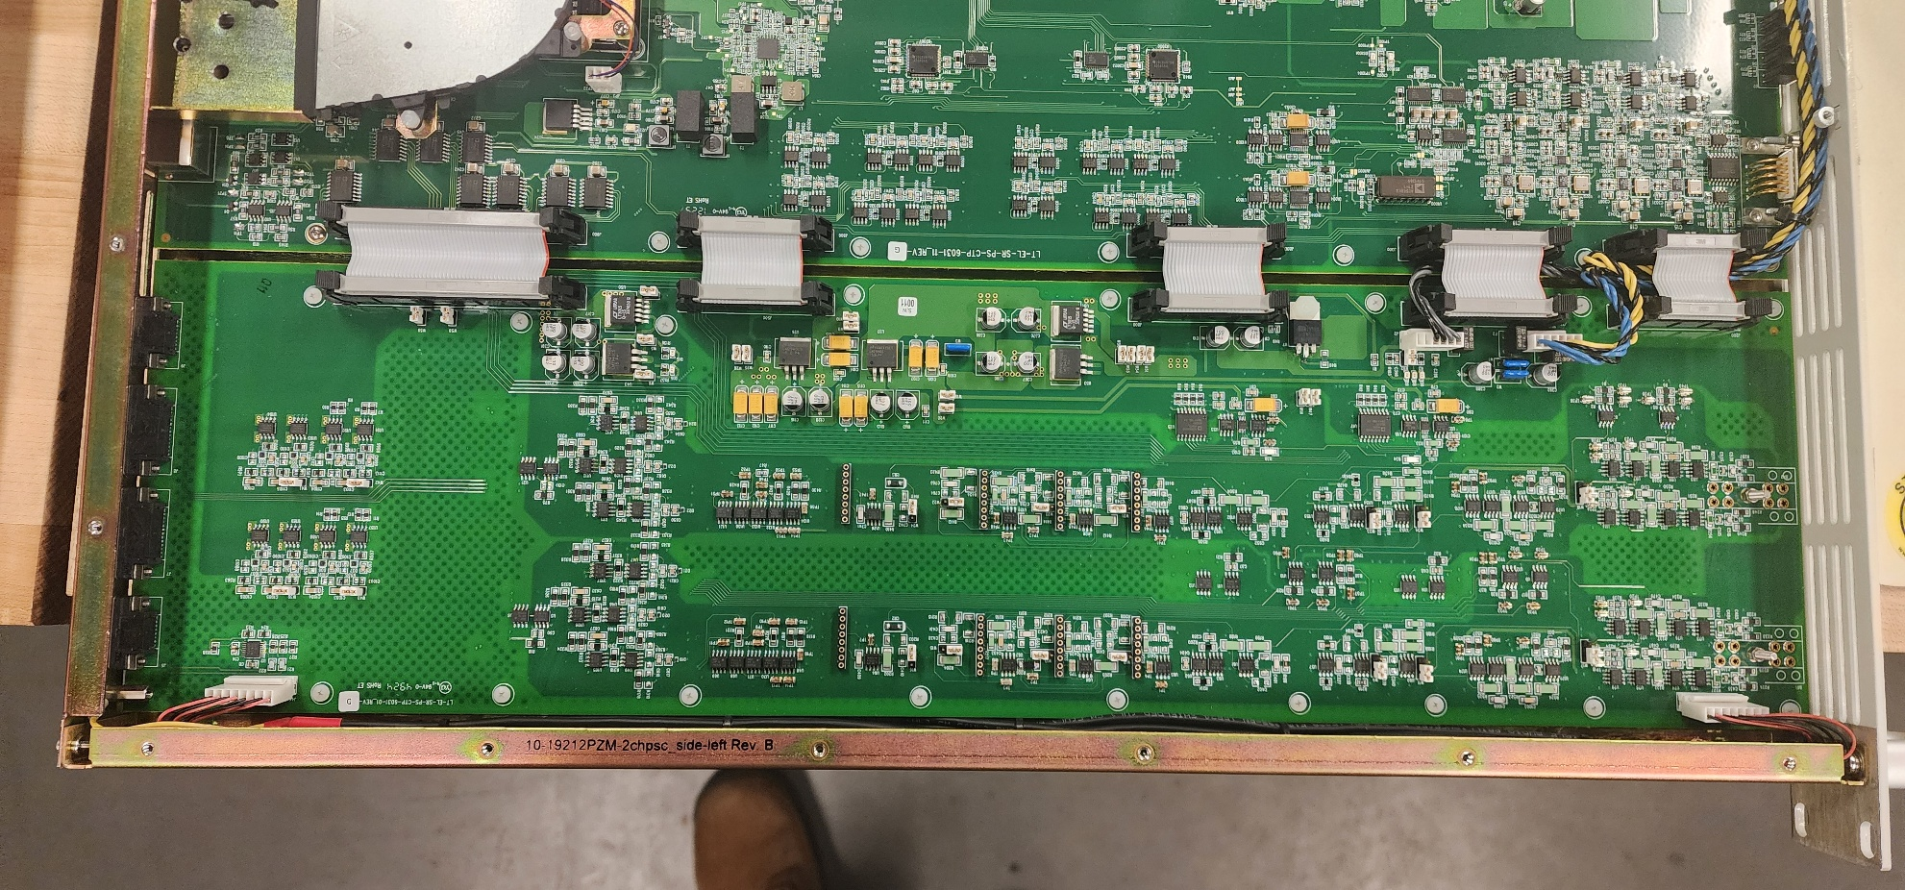
Burden Resistors
Comp C ($K_{i})$
Comp R ($Kp)$
Unipolar/Bipolar Diode Clamp
(Short for unipolar)
(Open for bipolar)
DCCT Cables
DCCT Cables

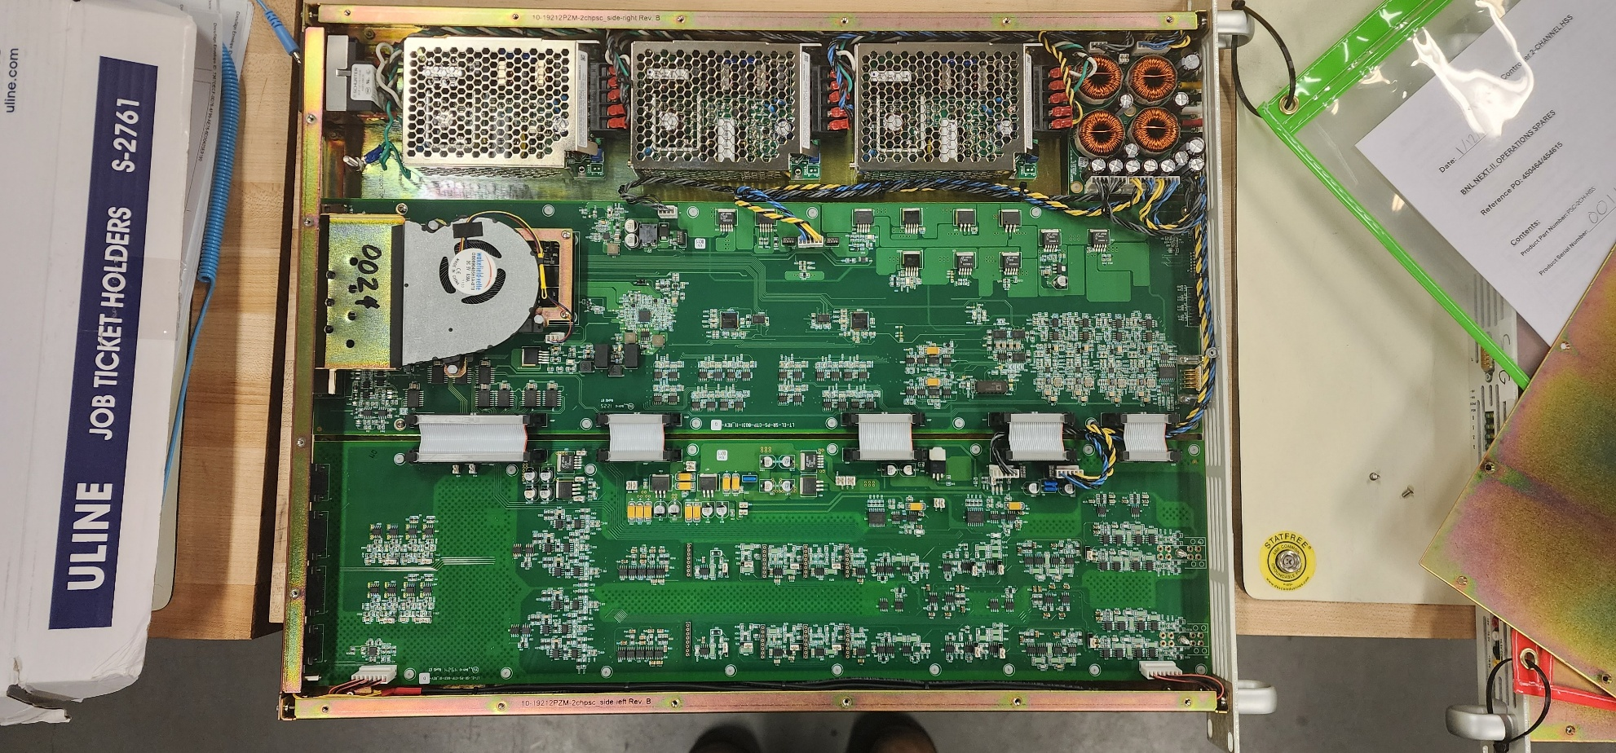

P/S#2
P/S#4

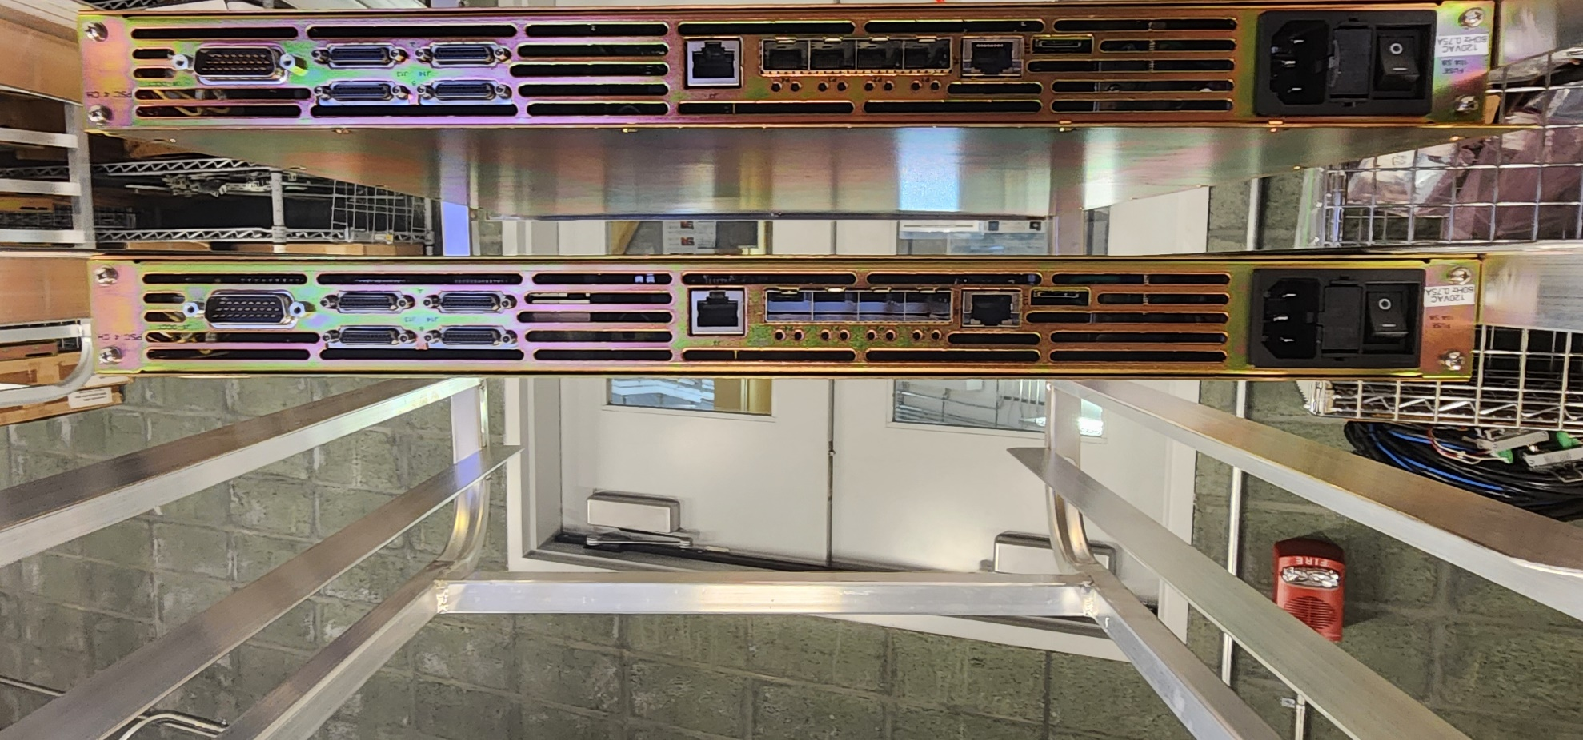
SD Card
“SFP1”FOFB
Network (IOC)
DCCT
P/S#1
P/S#3
One-Wire Port (Unused)
“SFP2”FOFB
“SFP3”
Event Receiver/Fiber Timestamp

